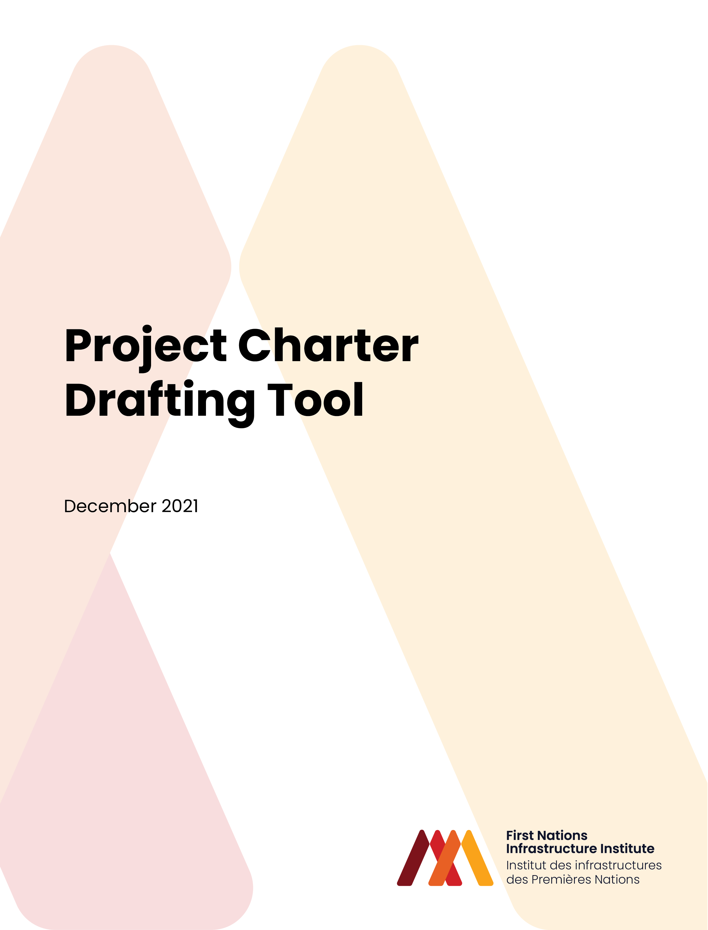

- Purpose
  - Establish relationship
  - Identify roles and responsibilities
  - Provide an outline of proposed project
  - Identify additional parties
  - Clearly document expectations including protocols for communications
- Definitions
- Project Overview
  - Background
  - Project scope
  - Timelines
- Principles to guide the relationship
  - All parties agree to work together in a mutually respectful manner
  - Promote the delivery of community benefits, knowledge transfer
  - Accountability and transparency
  - Cooperative relationship
- Key parties
- Governance
  - First Nation
    - Chief and Council
    - Chief Administrative Officer
    - Technical team
  - Regional Indigenous Organization
    - Board of Directors
    - Chief Executive Officer
    - Technical Team
  - First Nation Infrastructure Institute
    - Development Board
    - Technical Team
  - Project Team
- Roles and Responsibilities
- Ethical Framework
- Communications
- Dispute Resolution
- Appendix A: Activities and timelines Gantt Chart
- Appendix B: Project team details

