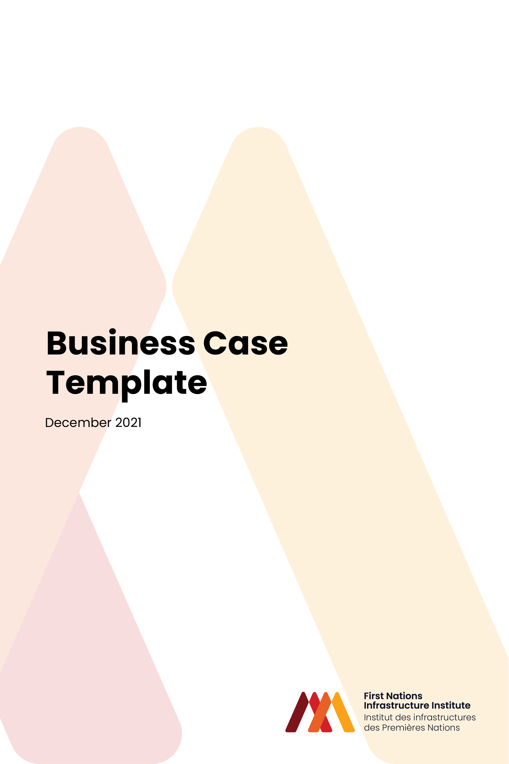
TABLE OF CONTENTS
STRATEGIC CASE 2
ECONOMIC CASE 4
COMMERCIAL CASE 6
FINANCIAL CASE 8
MANAGEMENT CASE 10

STRATEGIC CASE
- Executive Summary of Strategic Case
- Community Objectives in Relation to Infrastructure Project
  - Source documents for Objectives may include Comprehensive Community Plan (CCP), Strategic Plan, Infrastructure Master Plan or Similar Documents
  - Examples of Community Objectives may include (for example):
      - Health and Wellness
      - Community Safety
      - Environmental Integrity
      - Economic Development
      - Nation and Member Capacity Building
      - Cultural Preservation and Enhancement
      - Financial Sustainability
- Problems
  - Description of current problems, with reference to the Community Objectives
  - Description of the Current Infrastructure that may be causing those problems
      - Physical Attributes
      - Who is Served by Infrastructure?
      - Key Programming Elements (if relevant, such as recreation, cultural, educational and/or health programs within a building)
  - Challenges and Limitations of Current Infrastructure
      - Use List of Community Objectives above to frame discussion of challenges and limitations
- Benefits
  - Describe what benefits will be achieved if the identified problems are solved
- Solutions
  - High level description of improved infrastructure or other non-infrastructure solutions that could address challenges and limitations with current situation
- Project Objectives

  - Develop Project Objectives based off the Community Objectives and the identified problems (i.e. improve public health through delivering clean and potable water, enhance learning environment through providing sufficient / health / safe / culturally-appropriate educational space, etc.)
  - Ensure they are measurable, as they can be used to measure and demonstrate success of the project once complete

ECONOMIC CASE
- Executive Summary of Economic Case
- Description of potential Project Options
  - What is the Current Situation? (link to Strategic Case)
  - What Are the Project Options to Address the Current Situation?
      - Technical Characteristics
      - Scope of Service (i.e. geographic area of service, program scope, other)
- Comparison of Project Options
  - Comparison of Project Options to Set of Evaluation Criteria (evaluation criteria should be informed by Community Objectives and Project Objectives)
  - Option Comparison Can Be Done in Two Phases
      - Initial Evaluation of Long List of Options to Narrow Field to Short List
      - Detailed Evaluation of Short List
  - Link to Strategic Case for Objectives
- Cost and Revenue Analysis – Overview Level
  - Costs
      - Class C / D (or better if available) Capital Costs of New Infrastructure
      - Operation and Maintenance Cost Estimates
      - Major Anticipated Maintenance Costs to Sustain Life of Asset (i.e. roof replacement on building)
  - Revenues
      - Contributions from Canada (capital, operation and maintenance)
      - Other Sources
  - Link to Financial Case
- Detailed Description of Preferred Project Option
  - Detailed Description of Physical Characteristics of Preferred Infrastructure
  - Capital Costs
  - Operation and Maintenance Costs
  - Other Characteristics of Preferred Project Option to Meet Project Objectives (i.e. environmental mitigation, culturally-informed landscape and site development, engagement of First Nations community / members / businesses, etc.)
  - Next Steps in Moving Project Forward (Links to All Other Aspects of Business Case)

COMMERCIAL CASE
- Executive Summary of Commercial Case
- Procurement Objectives
  - Expectations (e.g., First Nation Involvement, etc.)
  - List of Procurement Objectives
- Bundling Assessment (if applicable, link to Economic Case section on technical options)
- Qualitative Procurement Options Analysis
  - Identification of Long-List of Procurement Options
  - Qualitative Assessment using Multi-Criteria Analysis
      - Using Procurement Objectives and Long-List of Procurement Options
      - Workshop to evaluate options, document rationale and arrive at a preferred option
  - Description of Preferred Procurement Option
- Qualitative Risk Allocation
  - Target risk allocation of Preferred Procurement Option
  - Link to Risk Management Framework included in Management Case
- Interaction with any Existing Commercial Arrangements
  - E.g., contracts with existing suppliers, etc.
- Procurement Strategy
  - Recommended approach to procurement
      - Market Sounding and Engagement
      - One vs. Two-Stage Procurement Process
      - Justification of strategy linking to desired outcomes (e.g., schedule certainty, time to market, availability of contractors, etc.)
- Form of Contract
  - Outline approach to contracting under the Preferred Procurement Option
      - Standard form contracts (e.g., CCDC, etc.)?
      - Applicable precedents?
- Indicative Procurement Timeline
  - Key milestones through the Procurement Process
      - Development of tender documentation and contracts
      - Release of tender documents to market
      - RFP Open Period
      - Evaluation of proposals
      - Appointment of contractor

FINANCIAL CASE
- Executive Summary of Financial Case
- Identification of Costs
  - Capital Costs
      - Appropriate class cost estimate from preferred option identified in Economic Case
  - Operating, Maintenance and Lifecycle Costs
      - Annual costs and lifecycle/renewal related costs
- Identification of Funding Sources
  - Capital Costs
      - Potential sources of funding for capital costs (e.g., ISC Grants, Monetized Transfers, FN Regional Organizations, FMA Tools, etc.)
      - Determination of appropriate capital funding sources for Project
      - Capital cost allocation between sources
  - Operating, Maintenance and Lifecycle Costs
      - Potential sources of funding for operating, maintenance and lifecycle costs (e.g., ISC O&M Contributions, Other Revenue, FMA Tools, FNGST, etc.)
      - Determination of appropriate operating funding sources for Project
      - Operating cost allocation between sources
- Whole of Life Financial Model
  - Forecast capital and operating costs
  - Forecast sources of funding for capital and operating costs
  - Appropriate inclusion of risks (e.g., construction and operating contingencies)
  - Sensitivity analysis
      - +/- X% for capital costs
      - +/- X% for annual operating costs
      - Financing assumptions (e.g., interest rates, etc.)
      - Economic assumptions (e.g., inflation rates, etc.)
- Affordability Assessment
  - Confirmation of Affordability
  - Proposed method for covering any Funding shortfall, if required
- Next Steps
  - Identify required next steps for confirming and receiving funding from identified funding sources
  - Timing for confirming and receiving funding

MANAGEMENT CASE
- Executive Summary of Management Case
- Project Management Arrangements
  - Local Capacity within First Nation or FN Organization
- Project Governance Arrangements
  - Organizational Chart for Governance
  - Roles and responsibilities from Chief and Council down to Project Team
  - Any other governing bodies (e.g., Tribal Council, FN Organization, ISC Regional, etc.)
- Project Team Requirements for Procurement and Implementation
  - Specialised skills required; internal and external
  - Strategy to address any gaps in skills
  - Role of FNII through Procurement and Implementation
- Risk Management
  - Identify key risks, impacts, and mitigation (with reference to section within Commercial Case)
  - Detail approach for managing risk throughout Project
  - Roles and responsibilities for Risk Management
- First Nation Engagement
  - Detail strategy for engaging First Nation(s) residents regarding the Project
  - Develop First Nation Engagement Plan
- Stakeholder Engagement
  - Identification of impacted parties (e.g. end users, local residents/businesses, neighboring municipalities, other First Nations, etc.)
  - Plan for type/frequency of engagement with identified groups
  - Develop Stakeholder Engagement Plan
- Project Plan and Milestones
  - Gantt Chart completed in MS Project or similar software
  - Detailing Project Plan from completion of business case through to operations
- Key Next Steps
  - Business Case Approvals
  - Funding Applications and Approvals
  - Procurement Process

