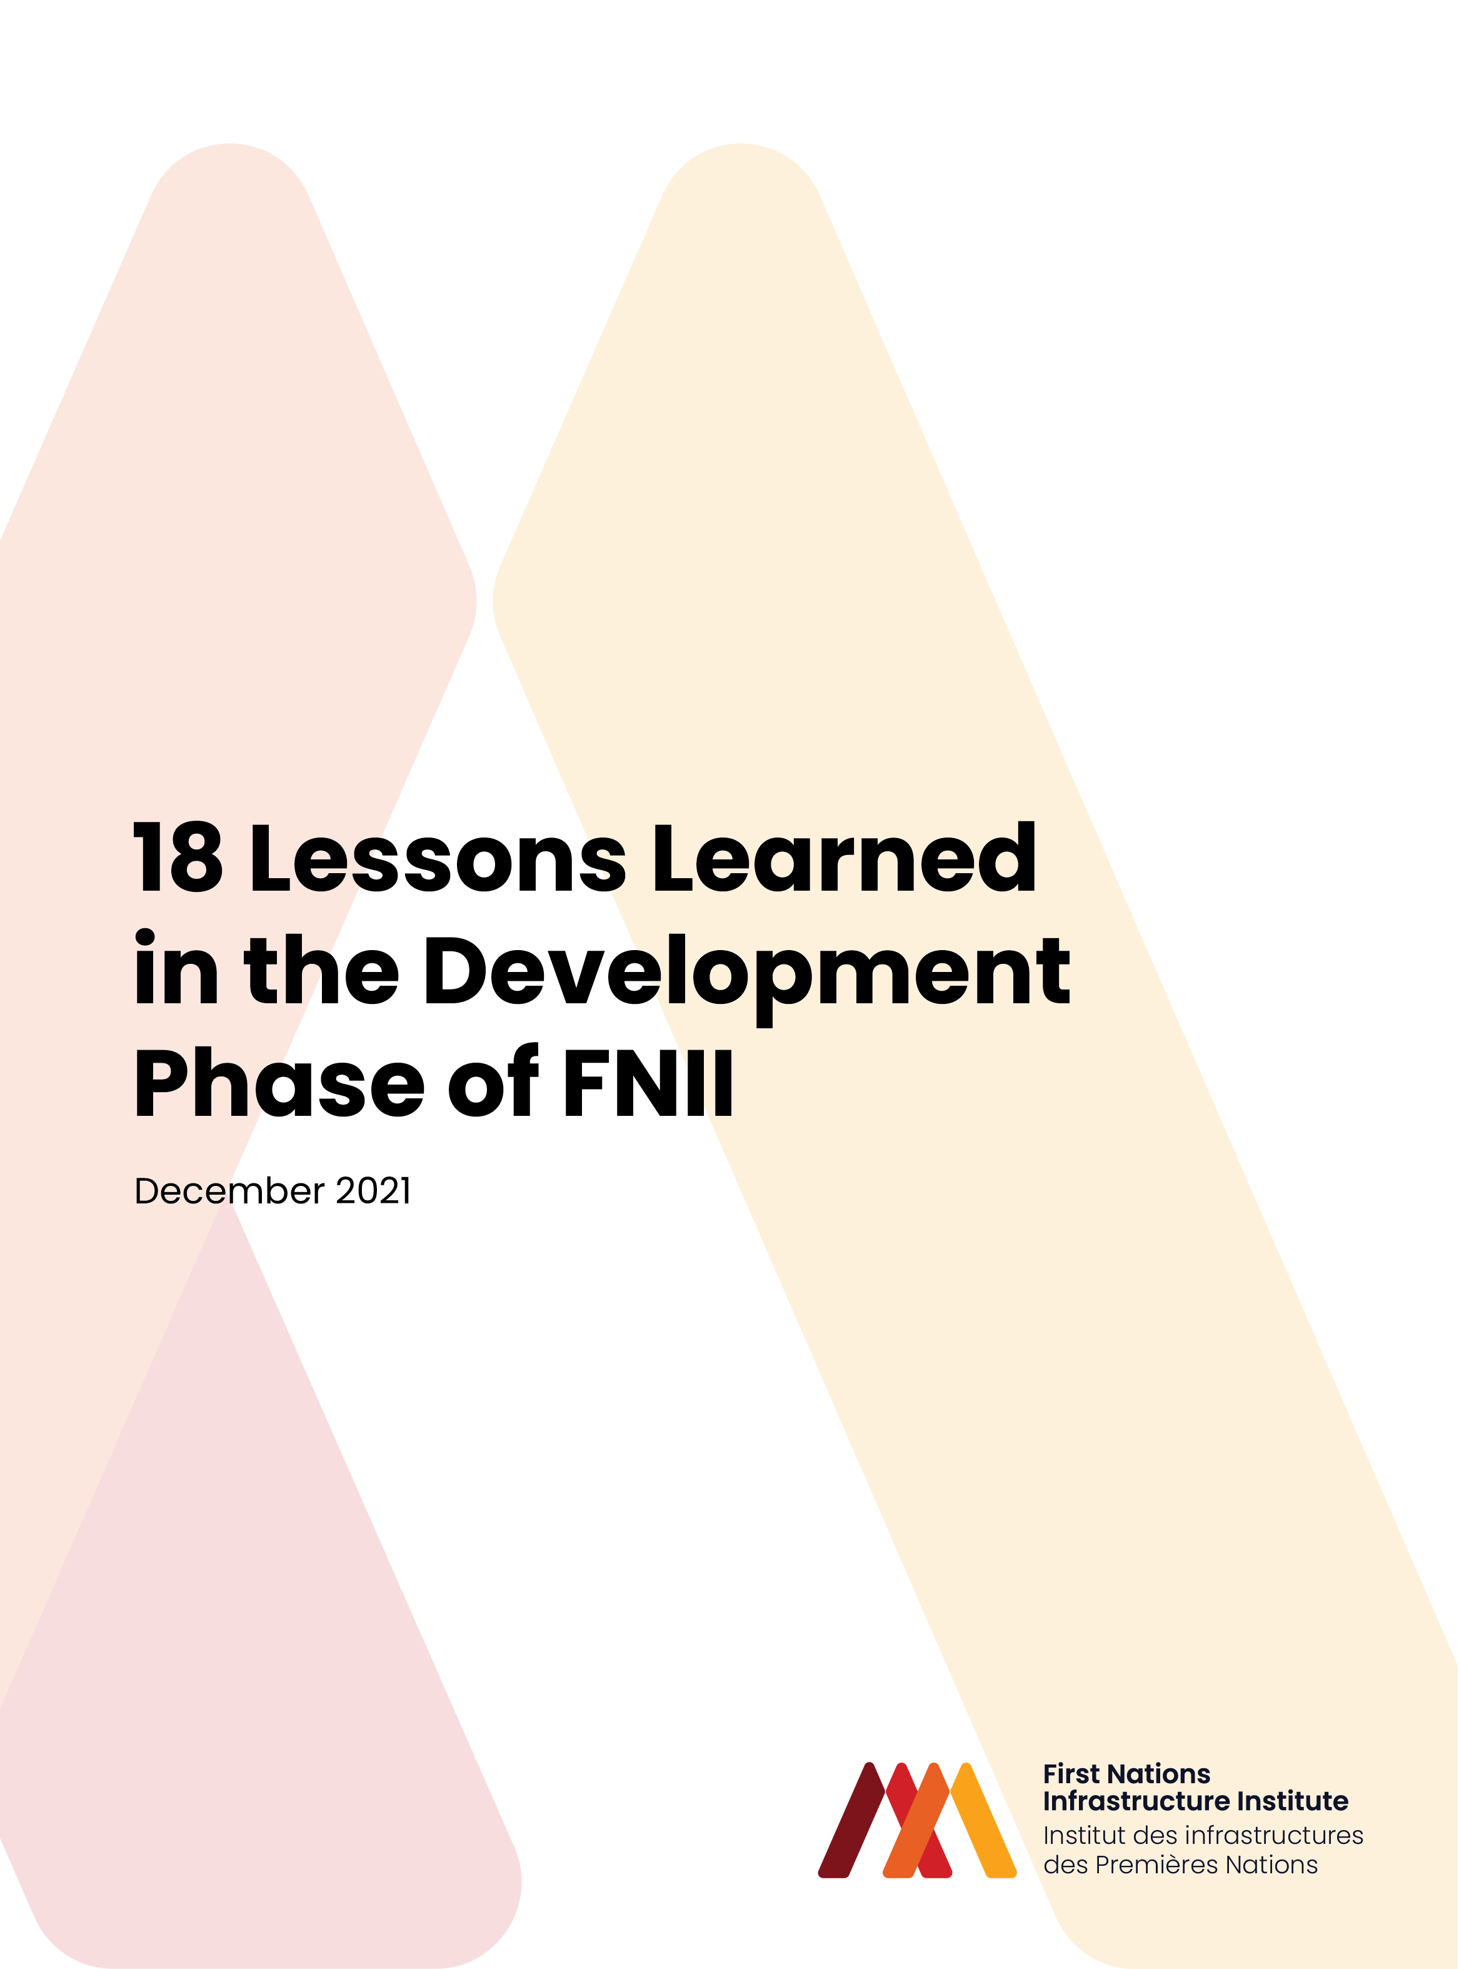

What we have learned

Since FNII was first imagined in 2017 and throughout its development phase, FNII has learned from First Nations and regional Indigenous organizations through a wide variety of engagements.
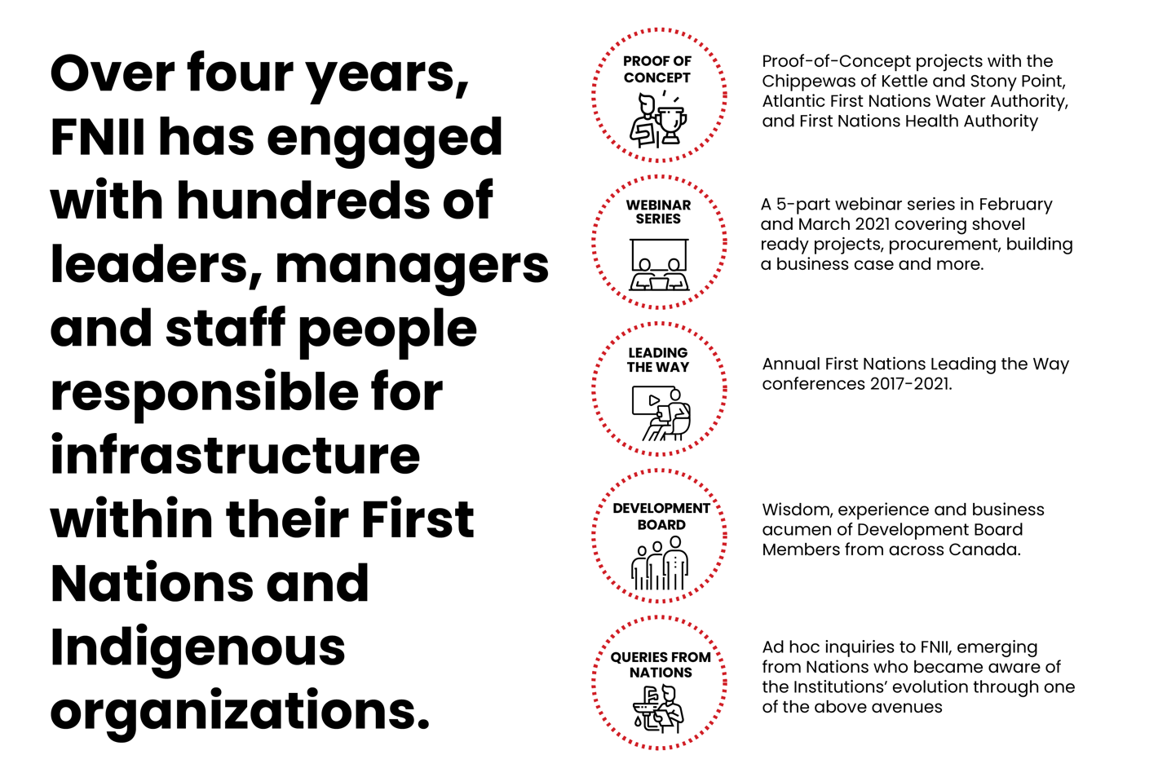
These engagements have informed FNII about the nature and scope of infrastructure development needs of First Nations in Canada.

KEY LEARNINGS

It is vital to consider the whole infrastructure project life cycle
The most common areas of focus for infrastructure projects are construction, and operations and maintenance. FNII’s work with Nations and Indigenous organizations has underscored the importance of the entire life cycle of infrastructure projects, from the earliest stages of pre-planning and problem definition through feasibility studies to select the most appropriate solution, followed by design, construction and then operations and maintenance. Beyond operations and maintenance, asset sustainability through rehabilitation of key asset components at appropriate times is also critically important.

A business case needs to be developed for all infrastructure projects
There are many dimensions of an infrastructure project. While the most appropriate technical solution – such as how to treat and distribute water; or, how to design a safe, comfortable and culturally reflective community building – are extremely important, there are many other considerations to be taken into account. FNII has developed a business case approach which reflects these considerations. The overall business case includes the following sub-cases which should be completed for all projects.
- Strategic Case – why is the infrastructure project required, and what Nation objectives does it address?
- Economic Case – what are the optional infrastructure solutions, and which one is preferred following evaluation from multiple perspectives?
- Financial Case – how will the infrastructure project be funded?
- Commercial Case – what is the most appropriate approach to Nation and other organization involvement in all phases of the building life cycle?
- Management Case – how will relevant parties come together and be organized to implement the infrastructure project?

Nations and Indigenous organizations have diverse needs
There is no one size fits all situation with respect to Nation and Indigenous organization need for support across the infrastructure life cycle. In contrast, FNII has found a diverse array of needs. Some communities have considerable experience and capacity to plan, operate and maintain their infrastructure, and require assistance only with technical design and construction (and in some instances, participating in construction through Nation member and business entity involvement). Other communities require more thorough support at each step along the infrastructure life cycle.
In the broader business case context described above, some communities have deep experience in funding infrastructure projects and bringing together various parties and sources to do so; others have less depth in these areas. To address these diverse needs, FNII applies the principle of meeting communities where they are. In some instances, FNII support would be required throughout the infrastructure project. In others, this support would be only in selected areas of the life cycle and/or business case.

A collaborative approach is critical to success
FNII has taken a collaborative approach to all Proof-of-Concept projects and community engagement during its formative period and believes firmly that this approach will be fundamental moving forward. This collaborative approach can be characterized by the following:
- Working with a spirit of togetherness and common interest, rather than adversity and divisiveness
- Seeking opportunities to guide Nations and Indigenous organizations through the relevant portion of the infrastructure life cycle according to their need, and mentor and advocate at each step in which FNII is engaged
- Ensuring common expectations which are clear and consistent throughout the infrastructure life cycle
- Maintaining positive, constructive and respectful relationships

Desire for capacity building
The communities with whom FNII has worked do not want FNII to simply do the work. In contrast, the Nations and Indigenous Organizations have welcomed the opportunity to work alongside FNII and gain experience and build capacity. This has occurred through in-person workshops and other contact via virtual platforms. And the experience and capacity gained by the communities has been diverse, ranging from finalizing contracts with outside agencies for feasibility studies to financial analysis, procurement qualitative assessments and other valuable and enduring skills.

Community engagement is key
FNII has witnessed time and again the need for and value of community engagement when undertaking infrastructure projects. This engagement needs to be broad in nature and include all dimensions of the community – membership, all staff who interface with an infrastructure project (such as operations, public works, finance, lands, and other staff), Chief and Council, Nation businesses, other stakeholders and partners – _as they all touch infrastructure projects in one way or another and need to be engaged. And this level of engagement should not be confined to a few steps in the project life cycle (such as design and construction) but should start early and continue through operations and maintenance, and on to asset sustainability / rehabilitation.

Importance of Community Planning – Strategic and Operational
Strategic-level documents are so important to set the foundation for infrastructure projects and the objectives which the community wants to achieve by completing the projects. FNII has found that those communities which have taken the next step and created operational-level plans are further-equipped to move forward with individual infrastructure projects. Ideally, these operational-level plans include:
- Land Use Plan – identifies the Nation’s land base, those areas slated for member and economic development activities which will require linear infrastructure (roads, water, wastewater, etc.) and community buildings, and the nature of land uses within those areas (residential, commercial, etc.). In communities where there are Certificate of Possession (CP) lands, it is very useful if the projected uses of those lands can be included along with commonly-held Nation lands
- Infrastructure Plan – lists of capital projects required to serve member and economic development needs, their priority, and ideally cost estimates (best available) and timing; individual infrastructure projects can then be drawn out of this overall community infrastructure plan
- Financial Plan – broad-level identification of sources of revenue to fund the capital, operation and maintenance, and asset sustainability / rehabilitation of each infrastructure project (particularly those which are higher priority).

Infrastructure beneficiaries can be diverse – So should sources of funding
The majority of the Nations and Indigenous Organizations with whom FNII interacted spoke about infrastructure projects which would benefit both Nation members directly (i.e. through providing clean water and safe, appropriate buildings), as well as economic development initiatives which were advanced by the Nation. In many cases, the same infrastructure project benefitted both Nation members and economic development activities (such as a common water supply or wastewater disposal system). Given that there are often diverse beneficiaries of infrastructure, it follows that there should be equally diverse sources of funding. These can be generally expressed as follows:
  - Member needs (for residences and community buildings) – _focus is Canada for sources of funding for capital, operations and maintenance
  - Economic development initiatives – cost recovery tools under the First Nations Fiscal Management Act including property and service taxes, development cost charges, user fees and other tools are very well-suited for application by Nations to fund their economic development-related infrastructure.

In some cases, Nations have reached into other own-source revenues (in addition to those derived through the Fiscal Management Act) to make up funding shortfalls. 4

Strong interest in monetization
Building on the prior point regarding diverse sources of funding, Nations and Indigenous Organizations both expressed to FNII their strong interest in monetization. These communities recognize that the Government of Canada and other partners with whom they are engaged may not be in financial positions to support large one-time expenditures for capital projects. Their thoughts have therefore turned to the methods which they often use with their own funding sources to support capital expenditures – _monetization. In this context, monetization means using a committed funding stream to support borrowing of a larger sum of money which is committed to a capital expenditure. Nations and Indigenous Organizations recognize the potential for broader applicability of this approach using committed funding streams from Canada and other partners and would welcome this in their communities.

Interoperability with Other First Nation Fiscal Management Act Institutions
FNII learned through engagement with other First Nation Fiscal Management Act institutions that there is strong interest in the interoperability of FNII with each of them, including: First Nations Financial Management Board, First Nations Finance Authority and First Nations Tax Commission

Clarification of roles and responsibilities throughout project life cycle
Infrastructure projects can be complex from several perspectives. They have long life spans, ranging from their point of conception in a comprehensive community plan or similar document to decommissioning, often many decades later. They involve many people along this life cycle, both within the host community and often outside where external partners are involved. And the nature of the experiences and skills required for an effective and efficient infrastructure project is incredibly varied – architects, engineers, contractors (with their range of trade skills), operators, accountants and financial managers, lawyers, elected officials and others are all examples. FNII has found that the key elements of a successful infrastructure project are not always clearly laid out, nor are the parties responsible for providing three key ingredients – funding, human resources, and decision-making responsibility. There is a significant opportunity to clarify infrastructure project roles and responsibilities at the project outset, and at key points in its evolution.

Importance of Project Charter
Building on the points raised above regarding roles and responsibilities, FNII is a strong advocate for use of a Project Charter where two or more entities are working together on an infrastructure project. A Charter is very valuable at the outset of the project, can look as far forward as is reasonably known, and can be revised and refreshed as the project life cycle evolves. A draft table of contents which provides a useful framework when developing a Project Charter is available on our website.

Working with Indigenous Organizations (b2b support)
Over fiscal year 2020-2021, FNII has had the opportunity for significant interaction with two Indigenous Organizations – the Atlantic First Nation Water Authority (with 15 signatory Nations in New Brunswick, Nova Scotia and Prince Edward Island), and the British Columbia First Nations Health Authority (with Province-wide reach). This has deepened FNII’s understanding of the valuable services which these organizations deliver to their members, including infrastructure along each phase of the life cycle (with AFNWA in the early stages of that given the formative state of the Authority). Much like individual Nations, these organizations have diverse needs, some of which FNII could be well-suited to fulfil. Examples which have arisen over the past year include infrastructure planning (linking strategic-level, land use, infrastructure and financial plans), procurement and alternative service delivery, and new approaches to infrastructure cost recovery (including blending sources, and monetization).

Need for flexibility of FNII when engaged with Nation or Indigenous organization
As noted earlier, infrastructure projects are often complex – they take time to develop, have long life cycles, and involve many people. During fiscal year 2020 – 2021, two events occurred which point to the need for flexibility when working through an infrastructure project with a Nation or Indigenous Organization. First was the COVID 19 pandemic. Prior to this public health situation, FNII had spent much time in face-to-face meetings with communities across Canada. As was the case with so many business and personal interactions across Canada, FNII had to pivot and begin utilizing virtual platforms such as Zoom and Microsoft Teams to remain engaged with communities. While not as ideal as in-person meetings, this new approach did allow FNII to continue to conduct business and support communities. It also revealed that a hybrid model of in-person / virtual contact could work in the future once the pandemic has passed. The second event was a Chief and Council election in a community where FNII is engaged. While there was a pause in key decision-making regarding the project to respect the process leading up to the election, and for a period afterward to allow Council to become established as a new grouping with some new roles, the project is now back on track and moving forward with momentum regained.

Partnering
In the context of this discussion, partnering means where two or more entities have common and/or complementary interests and objectives which are expressed through the development of infrastructure – buildings, water and wastewater systems, roads and so forth – within a First Nation. This infrastructure can facilitate joint use of a Nation’s land base and the roads and utilities which service it, as well as Nation buildings (such as a multi-purpose building that houses cultural, recreational, administrative, economic development and other uses under one roof). Where these and other partnering examples exist, FNII has learned that clear thinking is required as part of the infrastructure development process to ensure that planning, design, constructing, operating and maintaining, and financing activities are carried out in an equitable and transparent manner, founded on the benefiter pays principle.

Potential to streamline infrastructure development process
Much First Nation infrastructure is developed using the traditional design – bid – build process wherein an engineer or architect designs the utility, road or building, tenders the design and receives bids from contractors, awards the work to a selected contractor, who then builds the infrastructure. The infrastructure is then turned over to the owner – in this case the First Nation – to operate and maintain. This is a very common approach to infrastructure development across Canada and among all levels of government. There are emerging options which have potential to streamline the infrastructure development process. These include, for example, design – build, design-build-operate-maintain, construction management, and integrated project delivery. Each infrastructure project can assess the most appropriate option, given the nature of the project and the community. This assessment can be undertaken in both qualitative and quantitative terms. There is also potential to bundle projects where one Nation has more than one proposed infrastructure project, and/or where adjacent Nations have similar projects

Clarity of Operations and Maintenance – Components and Funding
FNII found through its engagements that the term ‘operations and maintenance’ is typically used in a very general manner and that there is much opportunity for elaboration of this vitally important aspect of the infrastructure life cycle. For illustrative purposes, operations and maintenance comprises a wide range of services - everything from routine day-to-day work to periodic (i.e. yearly) efforts, to less frequent yet vital major rehabilitation. Using the example of a building, this would include daily / weekly cleaning and janitorial; yearly furnace maintenance; and 25-year roof replacement. Funding sources to support this diverse range of services and activities is also key and should include setting aside reserve funds for the less-frequent rehabilitation activities which are vital to asset longevity.

Continuing importance of contribution agreements with Canada
As noted above, FNII engaged with many communities who have advanced economic development initiatives on their lands, along with the infrastructure to support those efforts. While many Nations have used their lands for economic development, require infrastructure to support this, and have taken on business and other partners to do so, there is still a core need in all Nations to provide for the needs of members. These include clean water, safe roads, functioning wastewater treatment and disposal systems, and proper buildings accommodating diverse Nation activities. Therefore, contribution agreements with Canada for capital, operations and maintenance, and asset replacement activities remain foundational for First Nations.

